# Untitled Quiz

Document created: 04.22.2020 18:30

## Quiz Settings

| Setting | Value |
| --- | --- |
| Passing score: | 80% |
| Total number of questions: | 5 |
| Number of questions to ask: | 5 |
| Answer submission: | Submit one question at a time |
| Number of quiz retries: | None |
| When quiz is finished: | Show slide with results |
| Send quiz results to instructor: | imaging.education@gmail.com |
| Send quiz results to user: | No |

### Intro Slide

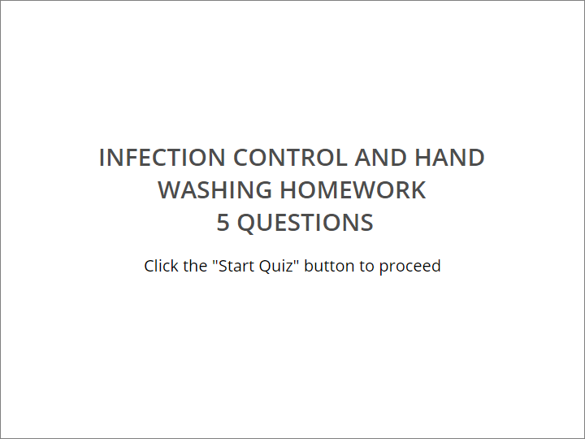

INFECTION CONTROL AND HAND WASHING HOMEWORK

​ 5 QUESTIONS

|  |
| --- |
| Click the "Start Quiz" button to proceed |

### User Info Form



Enter Your Details

| Field name | Condition |
| --- | --- |
| Name | Mandatory |
| Email | Mandatory |

### Quiz Instructions



​

|  |
| --- |
| * Before attempting, carefully read the question text. * Then choose the correct answer. * Click on **“Submit”** to confirm your answer. * Use the **Question List** in the upper left corner to jump to a certain question. |

## Question Group 1 (5/5 questions)

### Question 1. Multiple Choice, 10 points, 3 attempts

Which of the following is the most effective way to prevent infections?

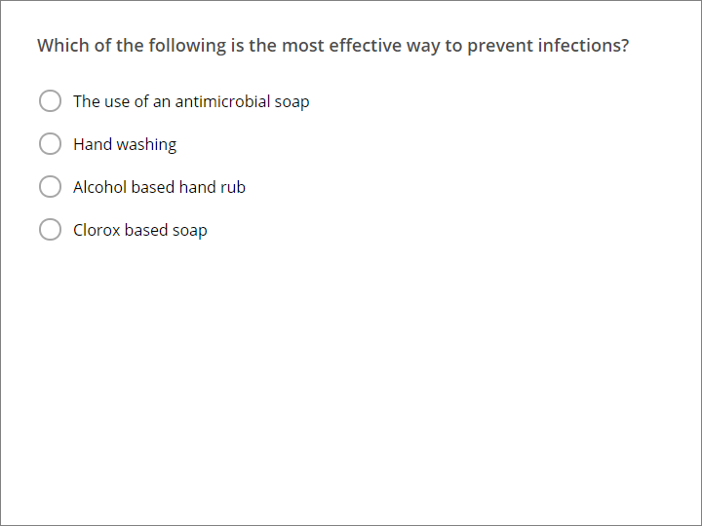

| Correct | Choices |
| --- | --- |
|  | The use of an antimicrobial soap |
|  | Hand washing |
| V | Alcohol based hand rub |
|  | Clorox based soap |

| Feedback | |
| --- | --- |
| Correct: | That's right! You chose the correct response. |
| Incorrect: | You did not choose the correct response. |
| Try Again: | You did not choose the correct response. Please try again.  ​  You have %ANSWER_ATTEMPTS% attempts. |

### Question 2. Multiple Choice, 10 points, 1 attempt

How often do you have to clean your hands after touching a patient’s intact skin?

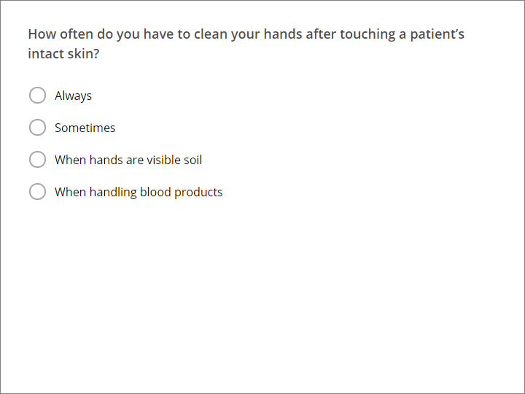

| Correct | Choices |
| --- | --- |
| V | Always |
|  | Sometimes |
|  | When hands are visible soil |
|  | When handling blood products |

| Feedback | |
| --- | --- |
| Correct: | That's right! You chose the correct response. |
| Incorrect: | You did not choose the correct response. |

### Question 3. Multiple Choice, 10 points, 1 attempt

What is the single most important reason for healthcare workers to practice good hygiene?

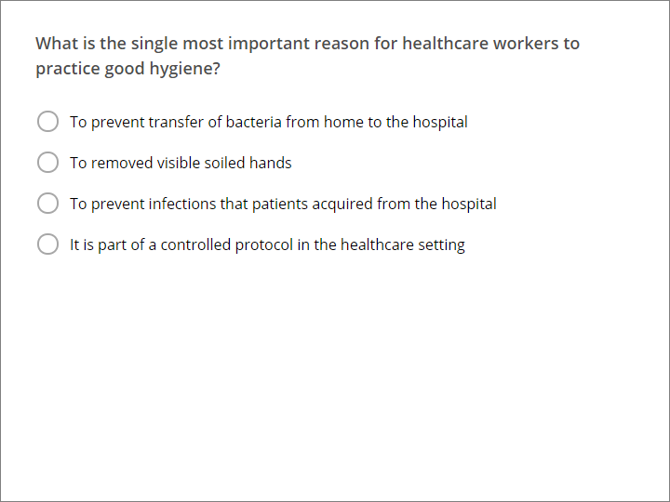

| Correct | Choices |
| --- | --- |
|  | To prevent transfer of bacteria from home to the hospital |
|  | To removed visible soiled hands |
| V | To prevent infections that patients acquired from the hospital |
|  | It is part of a controlled protocol in the healthcare setting |

| Feedback | |
| --- | --- |
| Correct: | That's right! You chose the correct response. |
| Incorrect: | You did not choose the correct response. |

### Question 4. Multiple Choice, 10 points, 1 attempt

It is acceptable for healthcare workers to supply their own lotions to relieve dryness of hands in the hospital?

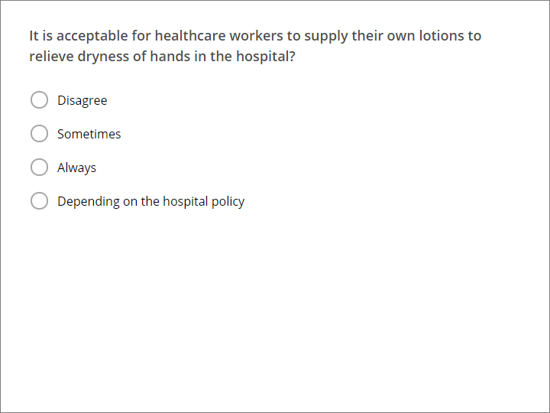

| Correct | Choices |
| --- | --- |
| V | Disagree |
|  | Sometimes |
|  | Always |
|  | Depending on the hospital policy |

| Feedback | |
| --- | --- |
| Correct: | That's right! You chose the correct response. |
| Incorrect: | You did not choose the correct response. |

### Question 5. Multiple Choice, 10 points, 1 attempt

How often do you have to clean your cleans after touching an environmental surface near patient. Example: bed rail, counter top?

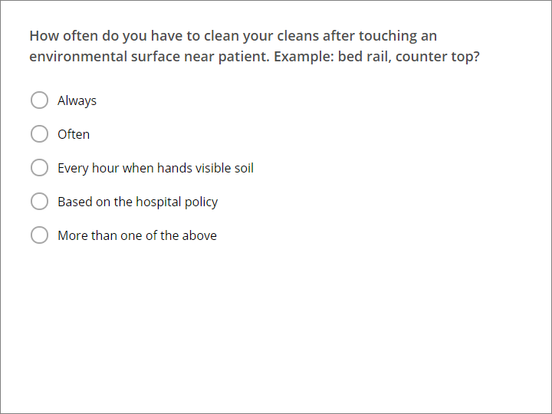

| Correct | Choices |
| --- | --- |
| V | Always |
|  | Often |
|  | Every hour when hands visible soil |
|  | Based on the hospital policy |
|  | More than one of the above |

| Feedback | |
| --- | --- |
| Correct: | That's right! You chose the correct response. |
| Incorrect: | You did not choose the correct response. |

## Quiz Results

### Quiz Results, Passed



Congratulations, you passed!

### Quiz Results, Failed



You did not pass.