Untitled Quiz
Document created: 04.21.2020 17:27

Quiz Settings
Setting | Value
Passing score: | 80%
Total number of questions: | 5
Number of questions to ask: | 5
Answer submission: | Submit one question at a time
Number of quiz retries: | None
When quiz is finished: | Show slide with results
Send quiz results to instructor: | imaging.education@gmail.com
Send quiz results to user: | No

Intro Slide
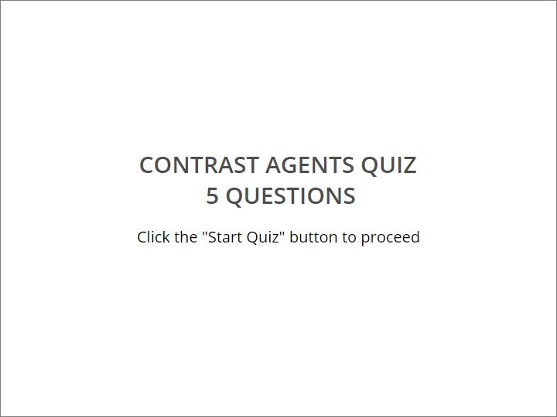

CONTRAST AGENTS QUIZ
​ 5 QUESTIONS
Click the "Start Quiz" button to proceed

User Info Form
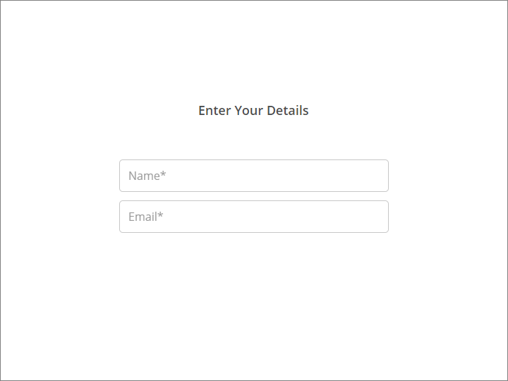

Enter Your Details

Field name | Condition
Name | Mandatory
Email | Mandatory

Quiz Instructions
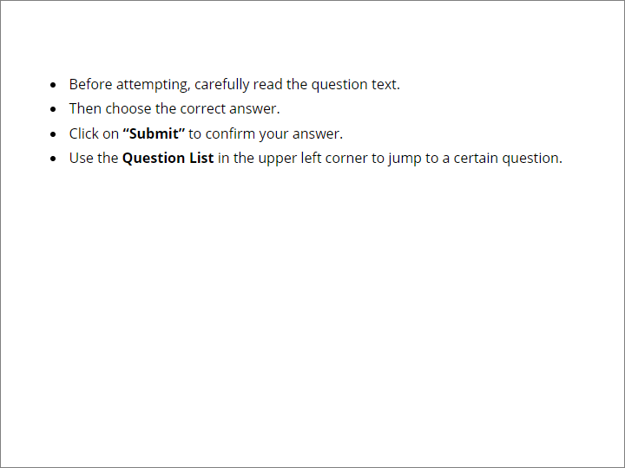

​
- Before attempting, carefully read the question text.
- Then choose the correct answer.
- Click on “Submit” to confirm your answer.
- Use the Question List in the upper left corner to jump to a certain question.

Question Group 1 (5/5 questions)

Question 1. Multiple Choice, 10 points, 3 attempts
What are desirable features of a contrast agent?

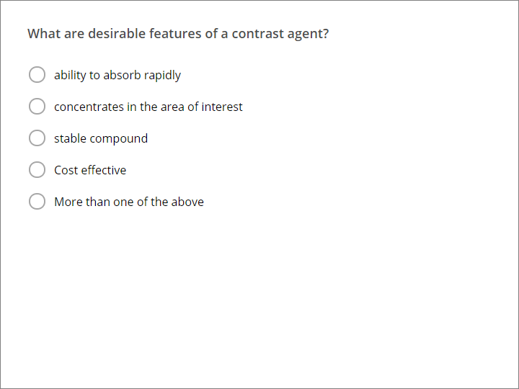

Correct | Choices
 | ability to absorb rapidly
 | concentrates in the area of interest
 | stable compound
 | Cost effective
V | More than one of the above

Feedback
Correct: | That's right! You chose the correct response.
Incorrect: | You did not choose the correct response.
Try Again: | You did not choose the correct response. Please try again.  ​  You have %ANSWER_ATTEMPTS% attempts.

Question 2. Multiple Choice, 10 points, 1 attempt
How can we reduced the viscosity of a contrast media?

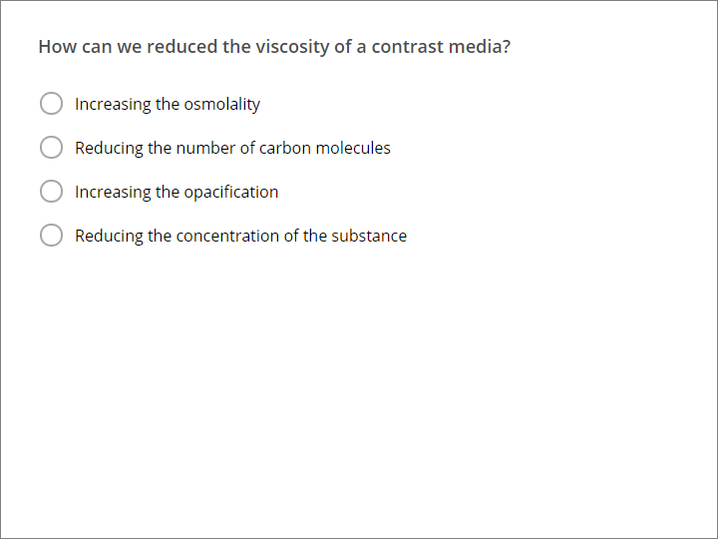

Correct | Choices
 | Increasing the osmolality
 | Reducing the number of carbon molecules
 | Increasing the opacification
V | Reducing the concentration of the substance

Feedback
Correct: | That's right! You chose the correct response.
Incorrect: | You did not choose the correct response.

Question 3. Multiple Choice, 10 points, 1 attempt
All of the following are methods of contrast administration except:

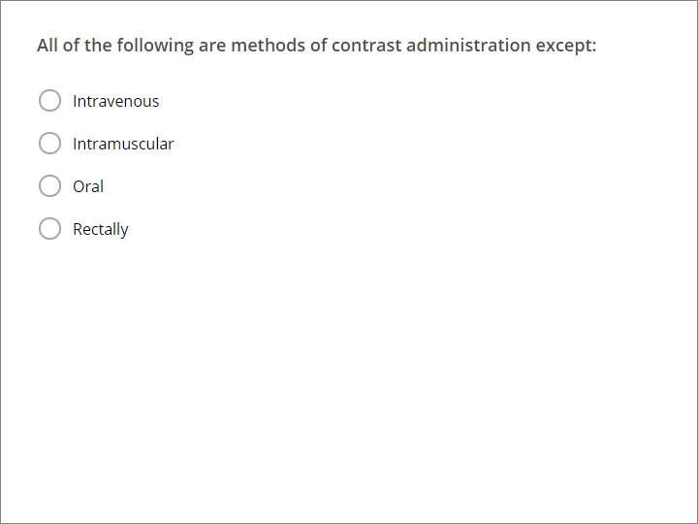

Correct | Choices
 | Intravenous
V | Intramuscular
 | Oral
 | Rectally

Feedback
Correct: | That's right! You chose the correct response.
Incorrect: | You did not choose the correct response.

Question 4. Multiple Choice, 10 points, 1 attempt
Severe Contrast reactions occur among what % of the population?

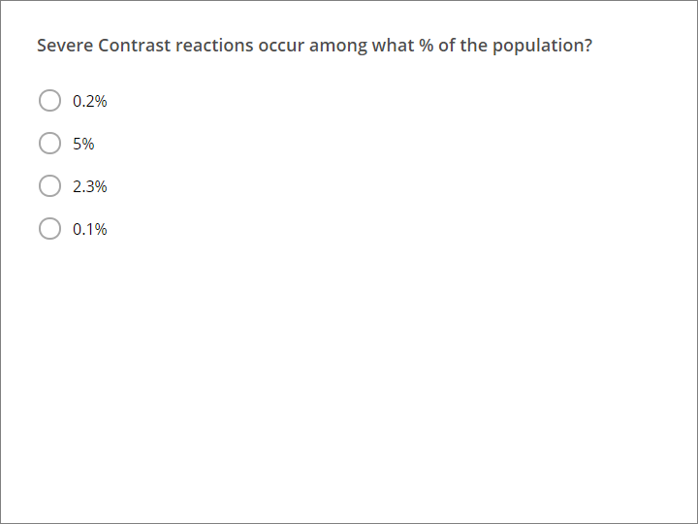

Correct | Choices
 | 0.2%
 | 5%
 | 2.3%
V | 0.1%

Feedback
Correct: | That's right! You chose the correct response.
Incorrect: | You did not choose the correct response.

Question 5. Multiple Choice, 10 points, 1 attempt
Which of the following studies is very accurate to perform for small bowel diseases?

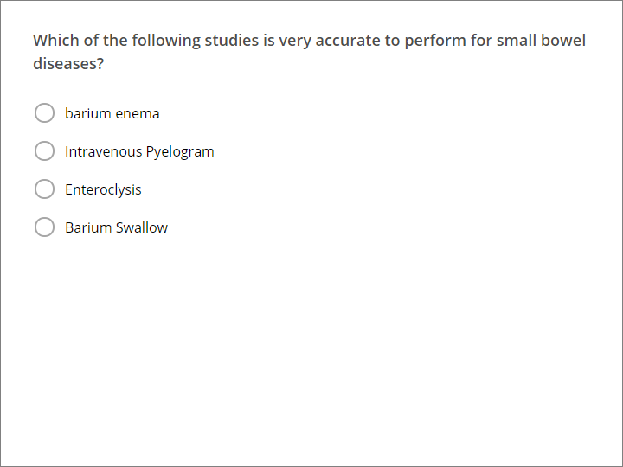

Correct | Choices
 | barium enema
 | Intravenous Pyelogram
V | Enteroclysis
 | Barium Swallow

Feedback
Correct: | That's right! You chose the correct response.
Incorrect: | You did not choose the correct response.

Quiz Results

Quiz Results, Passed
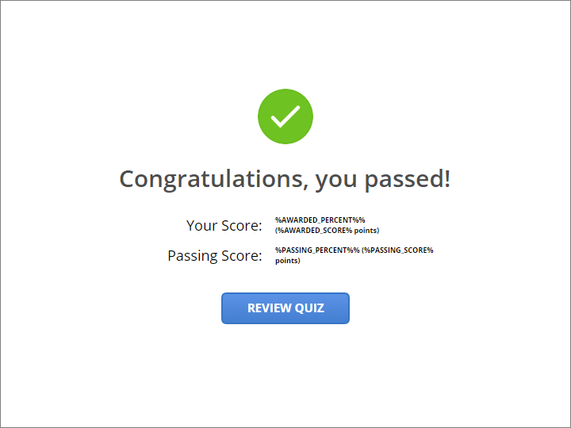

Congratulations, you passed!

Quiz Results, Failed
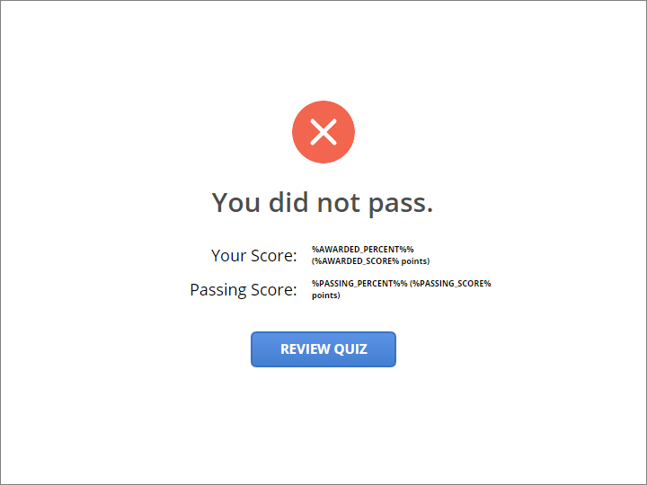

You did not pass.

