# Untitled Quiz

Document created: 04.21.2020 17:27

## Quiz Settings

| Setting | Value |
| --- | --- |
| Passing score: | 80% |
| Total number of questions: | 5 |
| Number of questions to ask: | 5 |
| Answer submission: | Submit one question at a time |
| Number of quiz retries: | None |
| When quiz is finished: | Show slide with results |
| Send quiz results to instructor: | imaging.education@gmail.com |
| Send quiz results to user: | No |

### Intro Slide

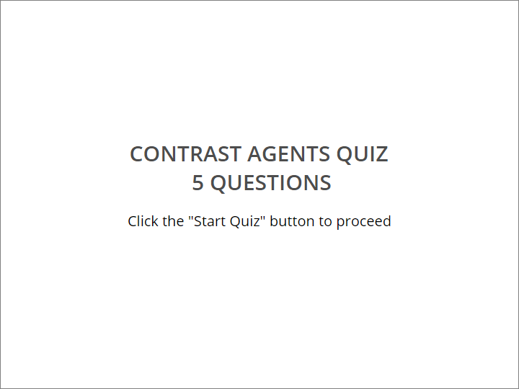

CONTRAST AGENTS QUIZ

​ 5 QUESTIONS

|  |
| --- |
| Click the "Start Quiz" button to proceed |

### User Info Form

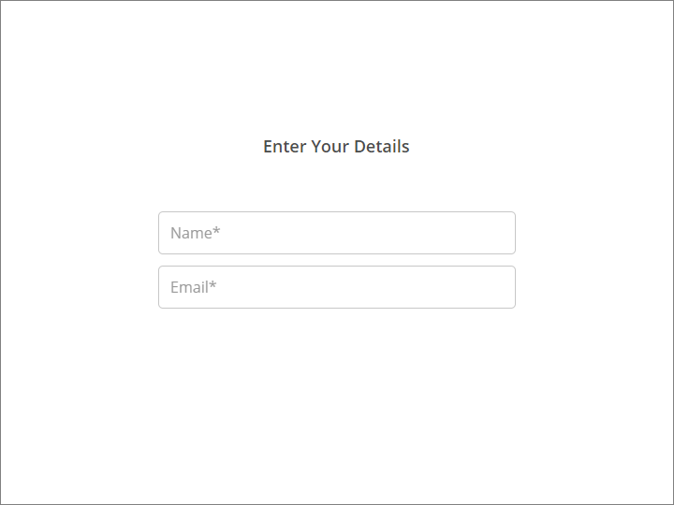

Enter Your Details

| Field name | Condition |
| --- | --- |
| Name | Mandatory |
| Email | Mandatory |

### Quiz Instructions

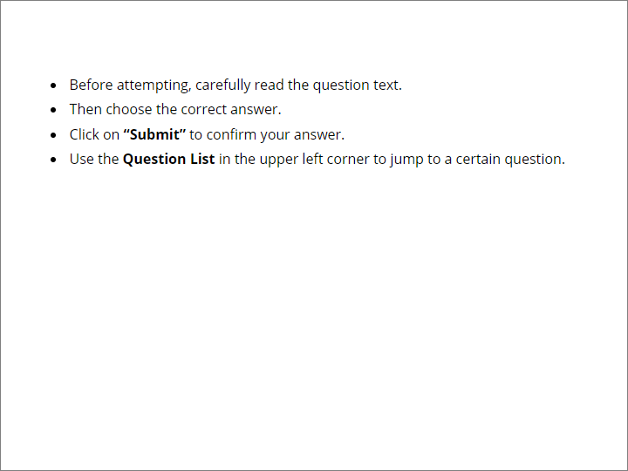

​

|  |
| --- |
| * Before attempting, carefully read the question text. * Then choose the correct answer. * Click on **“Submit”** to confirm your answer. * Use the **Question List** in the upper left corner to jump to a certain question. |

## Question Group 1 (5/5 questions)

### Question 1. Multiple Choice, 10 points, 3 attempts

What are desirable features of a contrast agent?

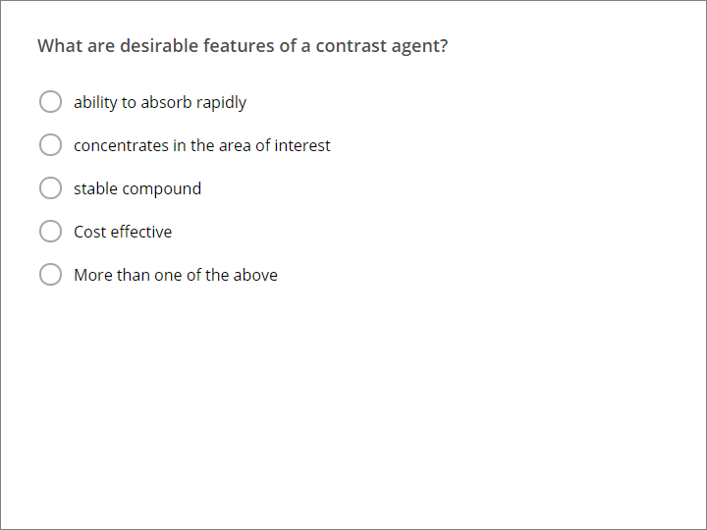

| Correct | Choices |
| --- | --- |
|  | ability to absorb rapidly |
|  | concentrates in the area of interest |
|  | stable compound |
|  | Cost effective |
| V | More than one of the above |

| Feedback | |
| --- | --- |
| Correct: | That's right! You chose the correct response. |
| Incorrect: | You did not choose the correct response. |
| Try Again: | You did not choose the correct response. Please try again.  ​  You have %ANSWER_ATTEMPTS% attempts. |

### Question 2. Multiple Choice, 10 points, 1 attempt

How can we reduced the viscosity of a contrast media?

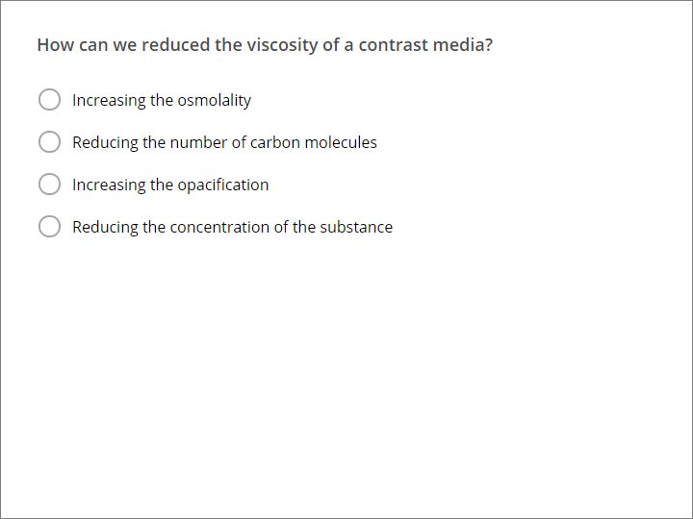

| Correct | Choices |
| --- | --- |
|  | Increasing the osmolality |
|  | Reducing the number of carbon molecules |
|  | Increasing the opacification |
| V | Reducing the concentration of the substance |

| Feedback | |
| --- | --- |
| Correct: | That's right! You chose the correct response. |
| Incorrect: | You did not choose the correct response. |

### Question 3. Multiple Choice, 10 points, 1 attempt

All of the following are methods of contrast administration except:

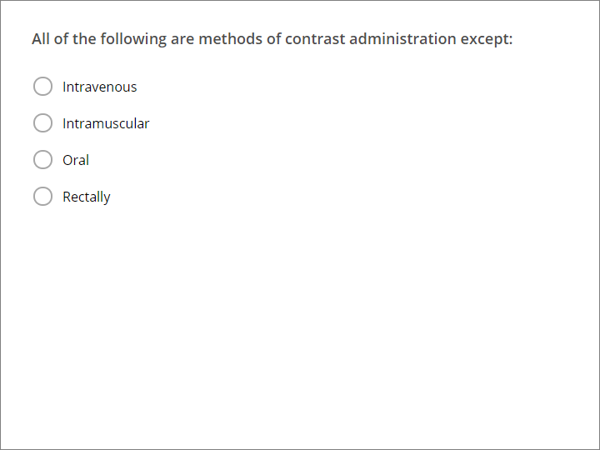

| Correct | Choices |
| --- | --- |
|  | Intravenous |
| V | Intramuscular |
|  | Oral |
|  | Rectally |

| Feedback | |
| --- | --- |
| Correct: | That's right! You chose the correct response. |
| Incorrect: | You did not choose the correct response. |

### Question 4. Multiple Choice, 10 points, 1 attempt

Severe Contrast reactions occur among what % of the population?

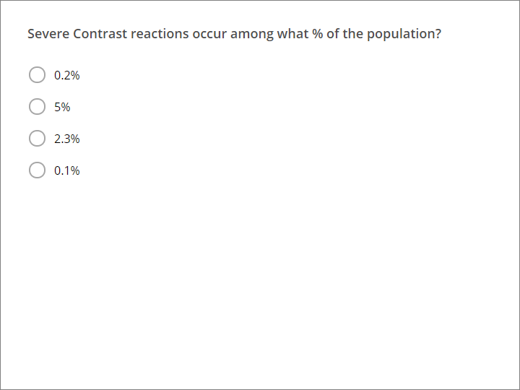

| Correct | Choices |
| --- | --- |
|  | 0.2% |
|  | 5% |
|  | 2.3% |
| V | 0.1% |

| Feedback | |
| --- | --- |
| Correct: | That's right! You chose the correct response. |
| Incorrect: | You did not choose the correct response. |

### Question 5. Multiple Choice, 10 points, 1 attempt

Which of the following studies is very accurate to perform for small bowel diseases?

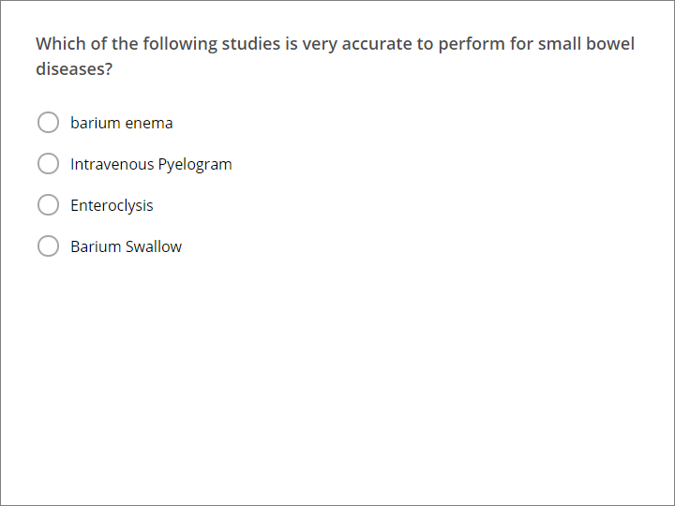

| Correct | Choices |
| --- | --- |
|  | barium enema |
|  | Intravenous Pyelogram |
| V | Enteroclysis |
|  | Barium Swallow |

| Feedback | |
| --- | --- |
| Correct: | That's right! You chose the correct response. |
| Incorrect: | You did not choose the correct response. |

## Quiz Results

### Quiz Results, Passed

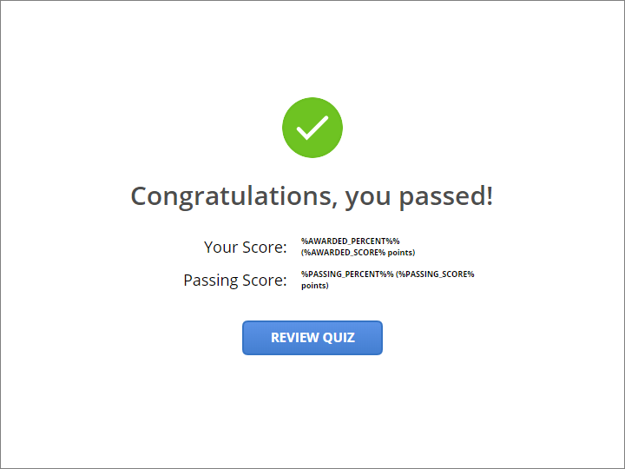

Congratulations, you passed!

### Quiz Results, Failed

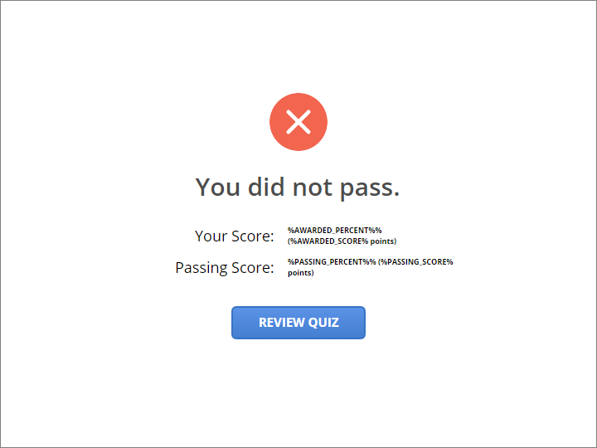

You did not pass.